9/18/13

Students’ Weekly Independent Rewards

Dear Parents/Guardians,

As a part of our classroom behavior plan, students are given the opportunity to choose a reward each week, from a long list of fun options. One of the options is to bring in something to share with the class. For this option, students are allowed to bring in a small pet. If a student chooses this and parental permission is granted, please follow the following procedures:

*Let me (the teacher) know what day you will be
coming with the pet so I can let the office know.

*Have the pet in an enclosed cage.

*Bring the pet to school during our recess time
ONLY (12:30-12:45) and then take the pet out of
the school when you leave.

*Please sign in at the front office, get a visitor’s pass
and only come to our classroom (room 501) with the pet.

Thank you and please contact me if you have any questions or concerns,

Mrs. Lela Studivan

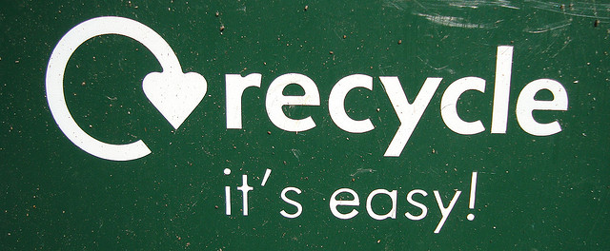 9/18/13

“Environmental Awareness”
Enrichment Unit

Dear Parents/Guardians,

I wanted to inform you of a new unit we will be starting during our enrichment period. We will be learning about our environment and ways to do our part in keeping it beautiful. Below are some topics we will be learning about:

*Recycling
*Litter
*The “Plastic Island”
*Human impacts on the environment
*Landfills and the impact we have when we do not recycle
*Composting
*Gardening and planting
*Educating our school/peers

The unit will be very hands-on and interactive for students. We will collect trash around our school and collect compostable materials during lunch, daily. We will compost on campus and work in the school’s garden each Friday (beginning on Friday, September 27th) in order to learn the importance of having trees and flowers in our environment and have some fun!

Please make sure your child has a change of clothes each Friday since we will be working in the garden (just in case we get a little dirty).

Please contact me if you have any questions, comments, or concerns,

Mrs. Lela Studivan

